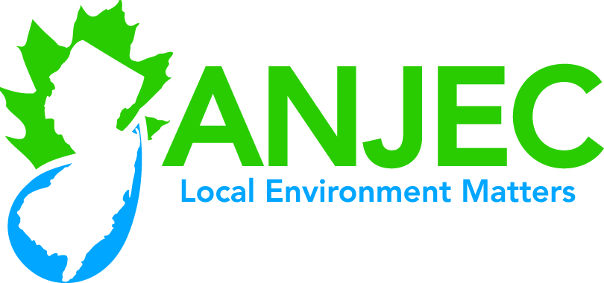

***Septic System Resources***

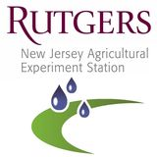

**Septic System Resources**

**Rutgers Cooperative Extension Service Water Resources Program**

The Rutgers Cooperative Extension Service Water Resources Program has published a number of highly informative “fact sheets” for those concerned with septic systems. These fact sheets are available in printable form from the Rutgers Cooperative Extension Service Water Resources Program, website at (<http://www.water.rutgers.edu/>

Included in this assortment are:

***On-site Wastewater Treatment Systems: The Maintenance and Care of Your Septic System*** (<http://njaes.rutgers.edu/pubs/publication.asp?pid=FS840>) Designed primarily for homeowners this 4 page fact sheet will educate homeowners about septic systems including: how septic system work, caring for your septic system, warning signs of a failing system, unsuitable locations, mound systems and alternatives. There is a list of contact addresses, and references.

***Onsite Wastewater Treatment Systems: Five Levels of Protection*** (<http://njaes.rutgers.edu/pubs/publication.asp?pid=FS531> This 4 page fact sheet will be of primary interest to environmental commissions, and elected officials concerned with improving the performance of septic systems in their communities and reducing public health and environmental risks caused by septic systems.

The importance of municipal management of septic systems is stressed, incentives are discussed, as are management considerations. “Five Levels of Protection” are presented, ranging from Homeowner Awareness (Level 1) through Maintenance Contracts (Level 2), Operating Permits, (Level 3), RME (Responsible Party Management Entity) Entity (Level 4) and RME Ownership (level 5).

“Level 1” (Homeowner Awareness) is required under the NJDEP Septic Rule. ***If your municipality is not regularly providing homeowners with adequate educational materials it is not in conformance with the DEP rule.*** Environmental commissions can play an important role in achieving this required objective by acquiring and distributing already prepared educational information to homeowners every three years. A periodic repeated workshop hosted by the environmental commission can also be given.

**ANJEC feels that “Level Three” (Operating Permits) is the most likely to win acceptance at the municipal level since a number of municipalities have adopted such ordinances.**

***Onsite Wastewater Treatment Systems: Operating Permits*** <http://njaes.rutgers.edu/pubs/publication.asp?pid=FS533>

This 4 page paper will be of interest to elected officials, boards of health, planning boards and environmental commission as well as homeowners (taxpayers). It deals with the ins and outs of establishing a septic operating permit in conjunction with a local ordinance (Level 3 protection). Public education is stressed as a pre-condition. Acceptance of a permit system will be easier if the public understands the need to manage septic systems correctly. Several case studies are presented from municipalities that have adopted permit systems. Fees are discussed as are staffing requirements.

***Onsite Wastewater Treatment Systems: Alternative Technologies*** <http://njaes.rutgers.edu/pubs/publication.asp?pid=FS532>

Primarily of interest to septic system designers, boards of health and site plan reviewers (environmental commissions and planning boards, this 4 page paper covers what are known as “alternative technologies” that can be applied to septic systems. Advantages, disadvantages, purchase cost and operation and maintenance costs are discussed. Technologies covered include: aerobic treatment units, fixed activated sludge treatment, recirculating sand filters, trickling filters, sequencing batch reactors, mound systems, subsurface drip systems, and peat fields are covered. A useful list of suppliers and installers is included although this may be dated since publication was in 2005.

***Onsite Wastewater Treatment Systems: Accessorizing Your Septic System***

<http://njaes.rutgers.edu/pubs/publication.asp?pid=FS532>

Of interest primarily to homeowners and installers, this brief two page fact sheet covers additions that can be made easily and cheaply to existing systems to improve performance and reliability. Covered are: baffles, gas deflection baffles, and effluent filters. The use of biological additives is dissuaded.

***Made possible by a grant from the William Penn Foundation***

